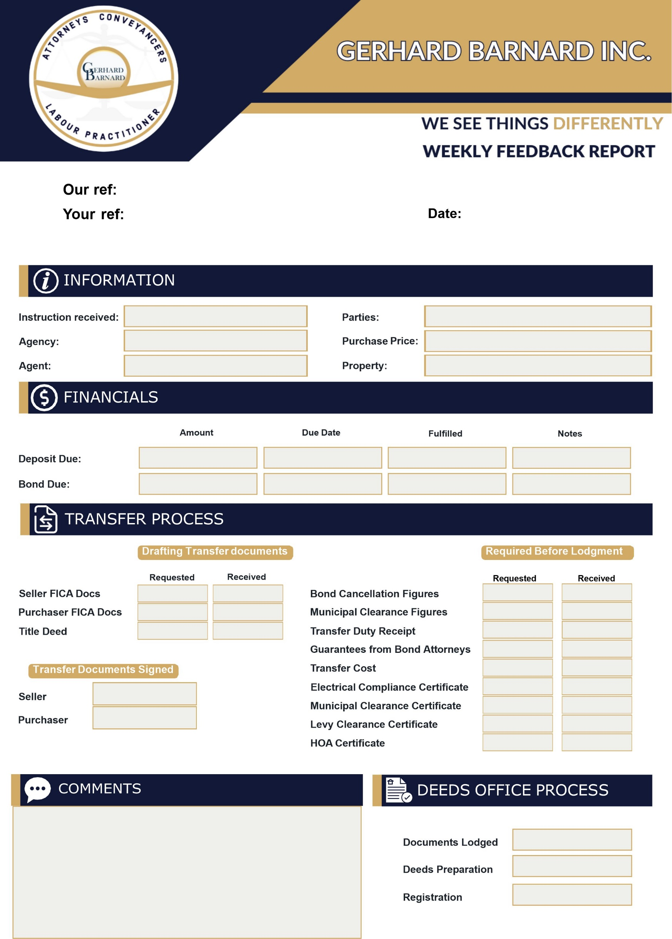

{{bc_vra}}

{{dep_ontv}}

{{dep_due}}

{{parties}}

22 MAY 2024

G Barnard/Karen/

{{reference}}